Wooden tables or pallets for block making machines
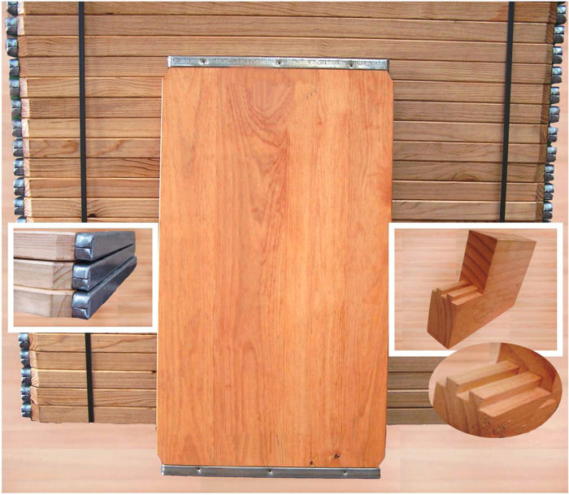

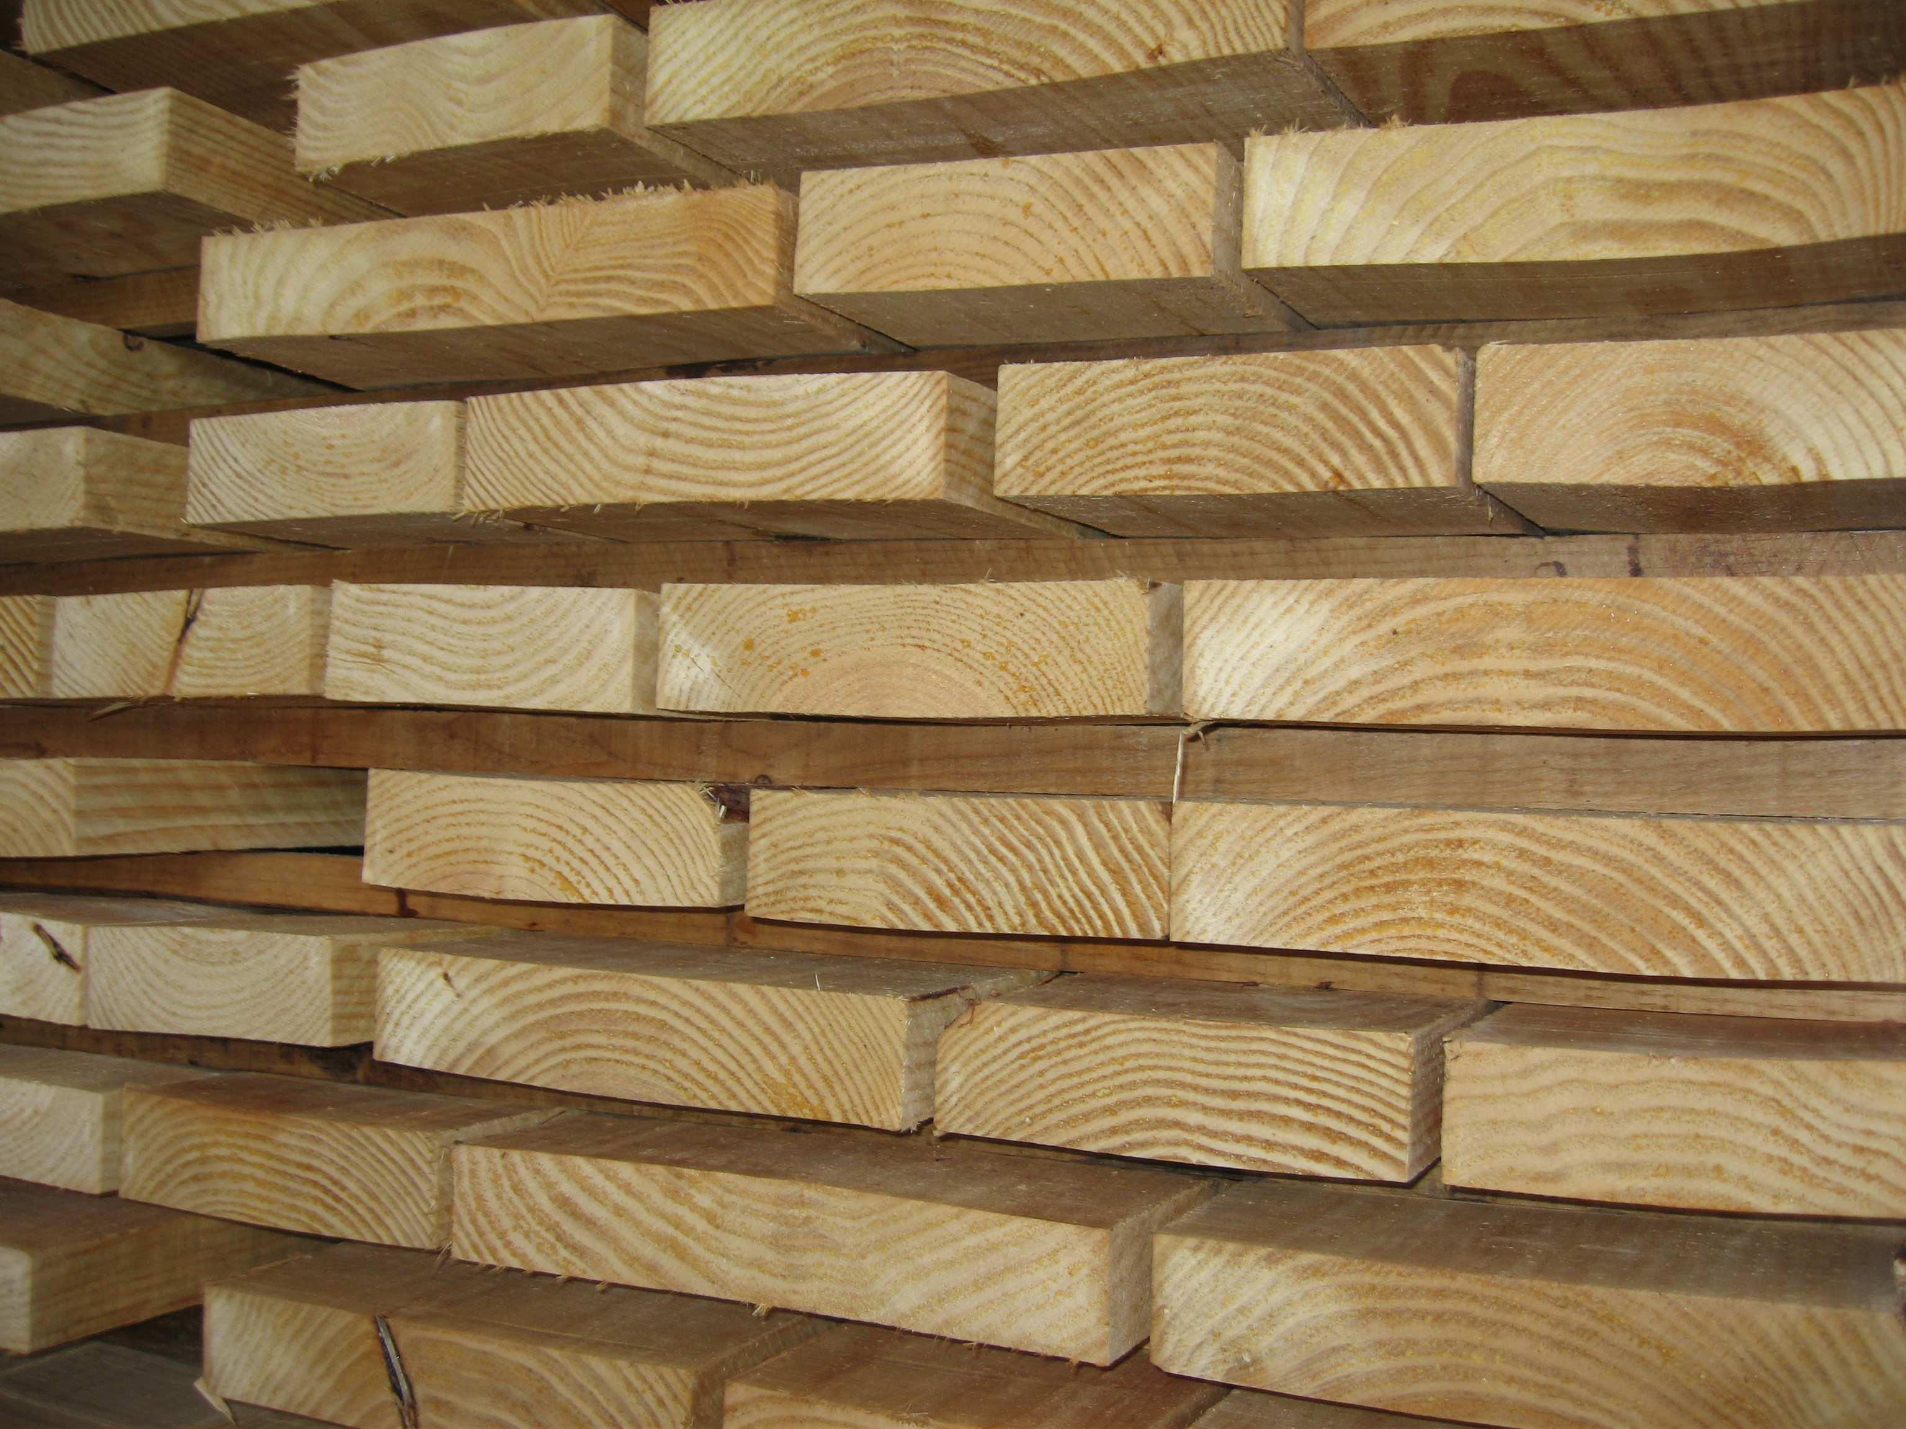
WOOD SELECTION
Pallets are made of
Pinus Pinaster, also known as
Maritime or Galician Pine.
All wood is sanded and rushed
on both surfaces.
Mechanical properties of
Pinus Pinaster:
Static flexion resistance: 795 kg/cm².
Module of elasticity: 74.000 kg/cm².
Compression resistance: 400 kg/cm².
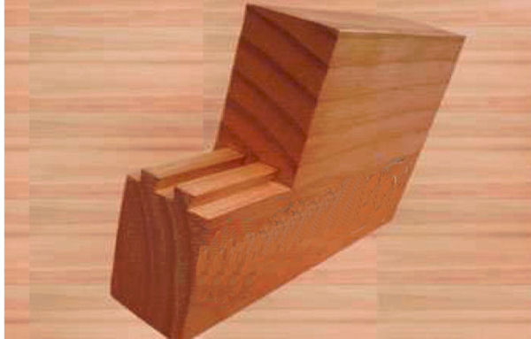
ASSEMBLY SYSTEM
We are the only manufacturers who use the double dovetail
system in the assembly of our products. Pallets do not need screw
bars or glue as the double dovetail system ensures the planks are bonded
together, thus favouring the natural dilatation and contraction of the wood,
and avoiding the apparition of cracks on the planks.
This system ensures product quality and guarantees:
- Pallet without warping.
- Homogeneous vibration in the
- whole surface.
- Shorter vibration time.
- Increased productivity.
- More homogeneous
- production.
- Saving of energy.

Double dovetail system assembly.
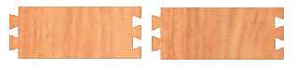
By the combination of different
factors like the mechanical properties
of elasticity and hardness of the
Pinus Pinaster and the ideal moisture
level of the wood obtained in our
heater, we can ensure that our Pallets have:
- High resistance and load capacity.
- Greater flexibility of use (less
weight than metal, plastic or
harder wood pallets).
Pallets are produced with boards of a single plank.
LATERAL PLANKS
We have incorporated wider and
rounded planks at the end of the boards, as well.
All these characteristics make the Pallets:
- Strong and reliable.
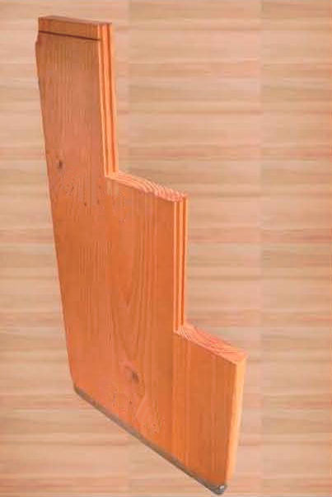
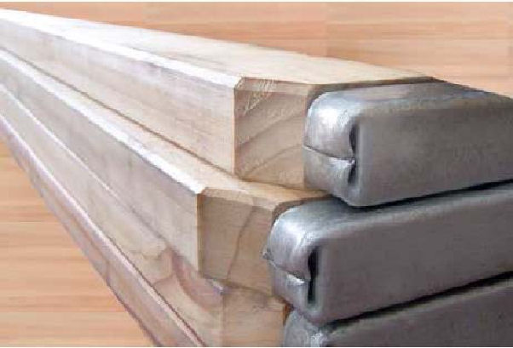
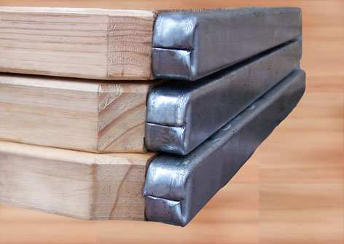
GALVANIZED PROFILE
Pallets have a galvanized profile of 2 mm thick..
The closing of the profile is made
folding the steel in a rounded way in the heads of the pallets, without
welding them (patented system in all
Europe).
This way we ensure that our
pallets do not hook in the machinery
and in the entry of the block making machine.
Even if this selection process is
more expensive, we consider that a
union in their length may produce a
weak point in the board.
PUNCH POINTS
This way the profile is properly
fixed to the planks and protects the
wood in the heads of the pallets.
Pallets are treated by way of immersion as part of the protection
process. Pallets are plunged in a proprietary preparation (oily and solvent base)
to keep them resistant.
This way the wood is effectively protected from fungi and humidity.
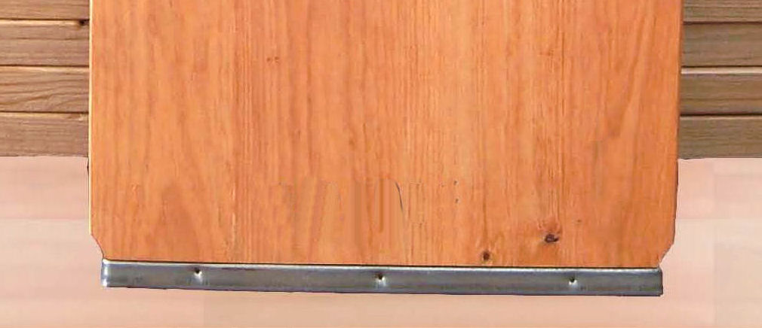
TREATMENTS
Pallets have six punch points (three on each side) hydraulically produced on the galvanized profile.
Our quality control is ISO 9001/2000
Certification accredited in 2005.
Is aware of the importance of the environment and endeavours through its production methods to help guarantee the
conservation of the forests.
For this reason we obtained the Chain of Custody Certification,
which guarantees that our wood comes from forests managed in a
sustainable way.
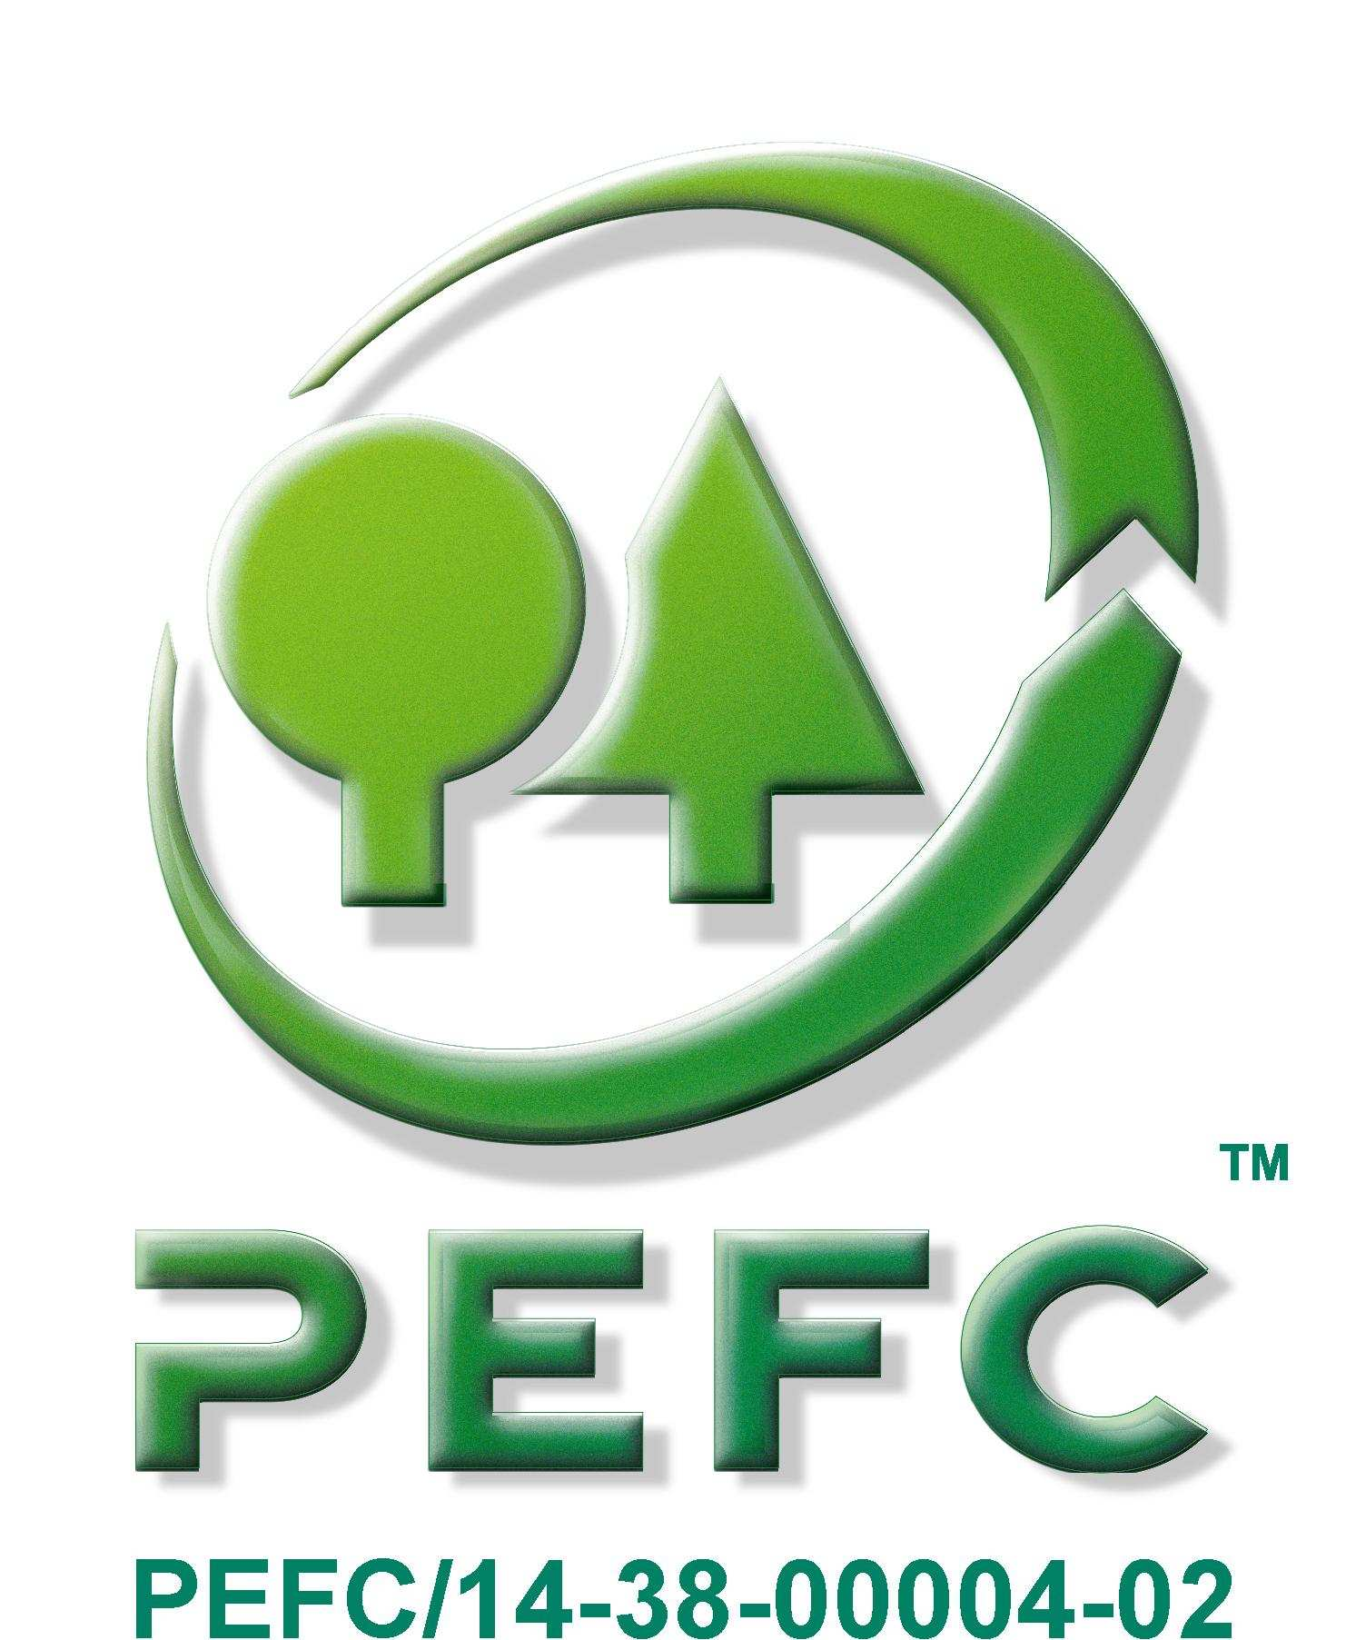
CERTIFICATIONS
has, as always, its main objective as the quality and the customer’s satisfaction, with which we maintain our privileged relationship around the world..
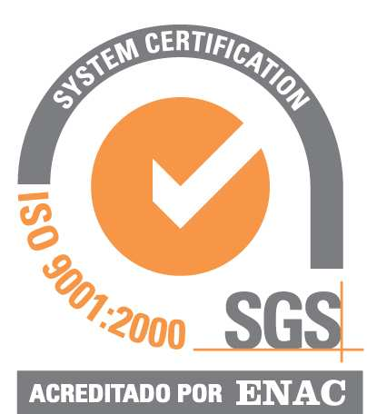
ISO CERTIFICATE
9001:2000
ES 05/0964
Our company has NIMF 15 Certification, whose stated is to
reduce all risks due to the spread of
harmful organisms transmissible by
the wood.
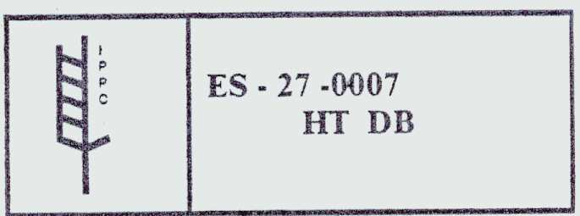
䄀猀猀攀洀戀氀愀最最椀漀......................

